Title Page

Title of Thesis or Dissertation

by

Author’s Full Name

Undergraduate degree, institution, year

Master’s degree, if applicable, institution, year

Submitted to the Graduate Faculty of the

Click to choose your school in partial fulfillment

of the requirements for the degree of

Click to choose your degree

University of Pittsburgh

Year

Committee Membership Page

UNIVERSITY OF PITTSBURGH

Click to choose your school

This thesis or dissertation was presented

by

Author’s Full Name

It was defended on

Select the Date

and approved by

Committee Member’s Name, Academic Rank, Department Affiliation

Committee Member’s Name, Academic Rank, Department Affiliation

Committee Member’s Name, Academic Rank, Department Affiliation

Thesis Advisor/Dissertation Director: Name Academic Rank, Department Affiliation

Copyright © by Author’s Full Name

Year

Abstract

Title of Thesis or Dissertation

Author’s Full Name, Abbreviation of degree, e.g., MA or PhD

University of Pittsburgh, Year

This is the abstract of the thesis, or dissertation. It should have no more than 350 words.

Table of Contents

Preface ix

1.0 Introduction: The First Chapter of Your ETD starts with Heading 1 1

1.1 Main Body Text 1

1.2 Consistency in Style Use 2

1.2.1 Heading Levels 2

1.2.2 Copying and Pasting from Another Document 2

1.2.2.1 Importing Styles 3

1.2.2.1.1 Using Alternate Fonts 3

1.3 Text Alignment 4

1.4 Using Styles Correctly Ensure Your Document is Accessible 4

2.0 Figures and Tables 5

2.1 Figures 5

2.1.1 In Line with Text 5

2.1.2 Alt Text 6

2.2 Caption Descriptions 7

2.2.1 Customized Numbering and Resetting the Number Count 8

2.3 Table Formatting 10

2.4 Updating the List of Figures or List of Tables 11

2.5 Permissions and Original Creations 11

Appendix A Appendices and Supplemental Content 12

Appendix A.1 Tables and Figures 12

Appendix A.1.1 Subsection Example and Appendix Captioning Advice 13

Appendix A.2 Adding Supplemental Documents 14

Bibliography 15

List of Tables

Table 1 Captions Go Above for Tables 10

Appendix Table 1 Letters and Number 13

List of Figures

Figure 1 Lackawanna Valley 6

Figure 2A and 2B. Dipictions of artists in their studios. 7

Figure 3A. A graph made from building blocks. 9

Figure 3B. A graph made from colored pencils. 9

Appendix Figure 1 Paragraph Mark 12

# Preface

It is recommended that acknowledgments, nomenclature used, and similar items should be included in the Preface.

The Preface is optional. If you wish to delete the Preface, you need to place the cursor in the Preface title and apply the Normal style to remove the currently applied style. Then delete the Preface content, being careful not to delete the preceding and subsequent sections. Be sure to also retain the Section Break(Next Page) that follows the Preface, so that the page numbering remains separated from the preliminary sections and the main body content.

# Introduction: The First Chapter of Your ETD starts with Heading 1

Each chapter of your ETD is proceeded with a number starting with 1.0 and uses the style Heading 1. To start a new chapter, press Return and select the Heading 1 style. When you create your second chapter you will see that it will automatically starts with 2.0. Many students begin their ETD with an introductory chapter, that provides on overview of the dissertation or thesis, but this is not required.

Your first chapter starts with Page 1 of your document and begins the main body of your document. The preceding pages are numbered with a lower-case roman numeral. The way that you order the content of your ETD is up to you, but it should follow a logical order using the different levels of the Heading hierarchy as explained below.

## Main Body Text

The main text of your ETD uses the Normal Style. You can apply the Normal style to any text sections in your document, the template is designed to apply the Normal style to the text succeeding a line using Heading 1-5.

To insert a new subsection, press Return to start a new line and then select the Heading 2 style from the Style menu.

## Consistency in Style Use

The most important thing to consider when adding elements to your ETD, is to aim for consistency. If you add block text or quotations that vary from the Normal style, your best bet is to create a style for that customization and use it throughout the document. It’s also best to minimize the amount of in-line editing that you do, as when you adjust a few lines of text that varies from the rest of the document, it will most probably be flagged on review.

### Heading Levels

You may have noticed that the Heading 3 style is left aligned, rather than the center alignment that Headings 1 and 2 use. That is intentional and adheres to the ETD Formatting Guidelines. You don’t need to adjust any of the formatting with the Headings that are included. This includes the number of spaces before or after the Headings. If you add an extra space after a Heading in one section but forget to put it in a later section, it may cause your ETD to be returned with an editorial comment.

### Copying and Pasting from Another Document

If you have started in another document or want to paste in text from a document formatted differently than the ETD template, you should try to paste it as unformatted text. This will allow you to then apply the Normal style and eliminate the chances that the external style could alter the styles included in the template.

#### Importing Styles

There are ways to import the styles from the template into another file, but if you haven’t been using the same named styles as the template uses, you may have a hard time getting everything to work as expected. In cases like that, you will need to import the styles and then make sure to reapply the proper styles to the sections and elements that you are including in your ETD.

##### Using Alternate Fonts

Though you can use other font families than Times New Roman, you will need to make sure the font you select is accessible and not going to cause any issues when converting to a PDF. You should avoid fonts that are script or may be unable to display symbols that may be used. The most accessible fonts to be considered are Times New Roman, Tahoma, Calibri, Helvetica, Arial, and Verdana. Remember that the final says on whether a font is acceptable remains with the Student Service staff member in your school.

To adjust the font family for your ETD, use the Font menu button to bring up the font selection menu. Find the font you want to use and set it to the desired weight, typically 12. Then select Use as Default and only in this document. This will then change the font for not only the body text, but the headings, page numbers, and any styles. If you select to change the font for the Normal template, it will change the default font for any document you make in the future but may not change the fonts in the ETD template as it uses a customized Word template.

## Text Alignment

The ETD template default text alignment is right/left justified. If you would prefer to have your text left aligned, you can modify the Normal style to be left justified by right-clicking on Normal in the Styles pane and selecting Modify. Then you select the alignment you would prefer in that menu. You should also be aware that other elements such as captions and bibliography entries may still be using different alignments. You shouldn’t need to adjust any of the Headings or other styles, but you should review the other sections to make sure no other alignments have been changed.

## Using Styles Correctly Ensure Your Document is Accessible

Using headings and other styles correctly throughout your document ensures that it is accessible to people with print disabilities. Screen readers and other accessibility technologies use styles to navigate the document. It is important that you use styles for emphasis instead of just adjusting the font of the text, as screen readers cannot recognize bold or italic but can recognize styles. For a Pitt ETD it is preferrable to use a sub-section for important text, but you can also use the styles **Strong (bold)** or Emphasis (italics)

# Figures and Tables

Figures should be edited and resized prior to inserting them into your document. It’s important to consider the resolution of your image so that it appears without any blurring and is readable. You should also refrain from using embedded PDFs to display documents, as you may not be able to create your final PDF document that displays the embedded PDFs the way you intended.

Tables should have tabular data in formatted cells. You should try to recreate any screenshot images of tables, so that the data is accessible to the reader.

## Figures

The figure below is inserted so that there is an item in the sample List of Figures. When you insert a figure, it is considered within the Normal style by Word. This means it will have a .5” first line indent. You can remove this by either dragging the indent marker to the left margin in the ruler, or by applying the style No Indent.

### In Line with Text

Sometimes when you import or paste in a figure, it will have text wrapping applied to it. Make sure that the figure is using the Layout Option -- In Line with Text. If you see a dashed line around the caption once you have inserted it, this means that text wrapping is applied to the related figure and the caption won’t be functioning properly in the List of Figures. If you are trying to have two or more images appear as a group, it may be best to combine those images in an image editing software and then import that file before trying to customize the layout of the page.

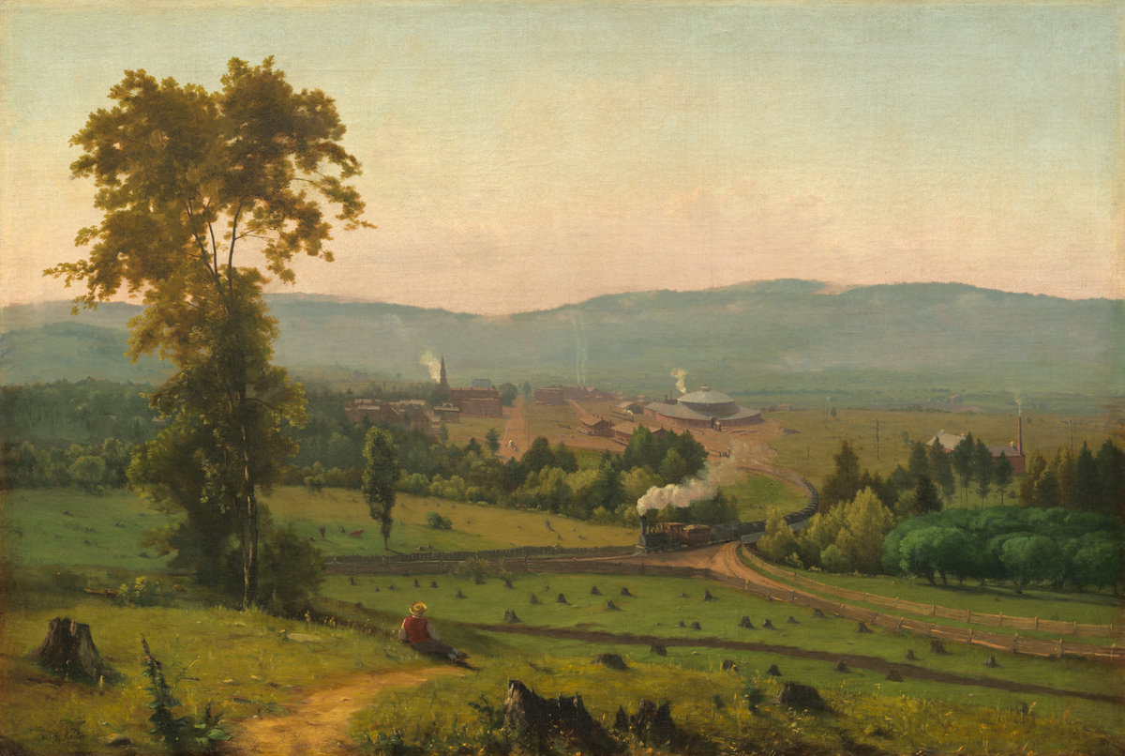

Figure 1 Lackawanna Valley

To insert a caption, right-click on the figure and select Insert Caption. It should be noted that captions go below image for figures but are placed above a table.[1]

### Alt Text

To aid in accessibility, click on the image you have inserted and use the Picture Format menu in the ribbon to select the Alt Text menu. Describe the image in a way that with a vision disability would be able to understand what is being shown. The description should detail the content and function of the figure.

## Caption Descriptions

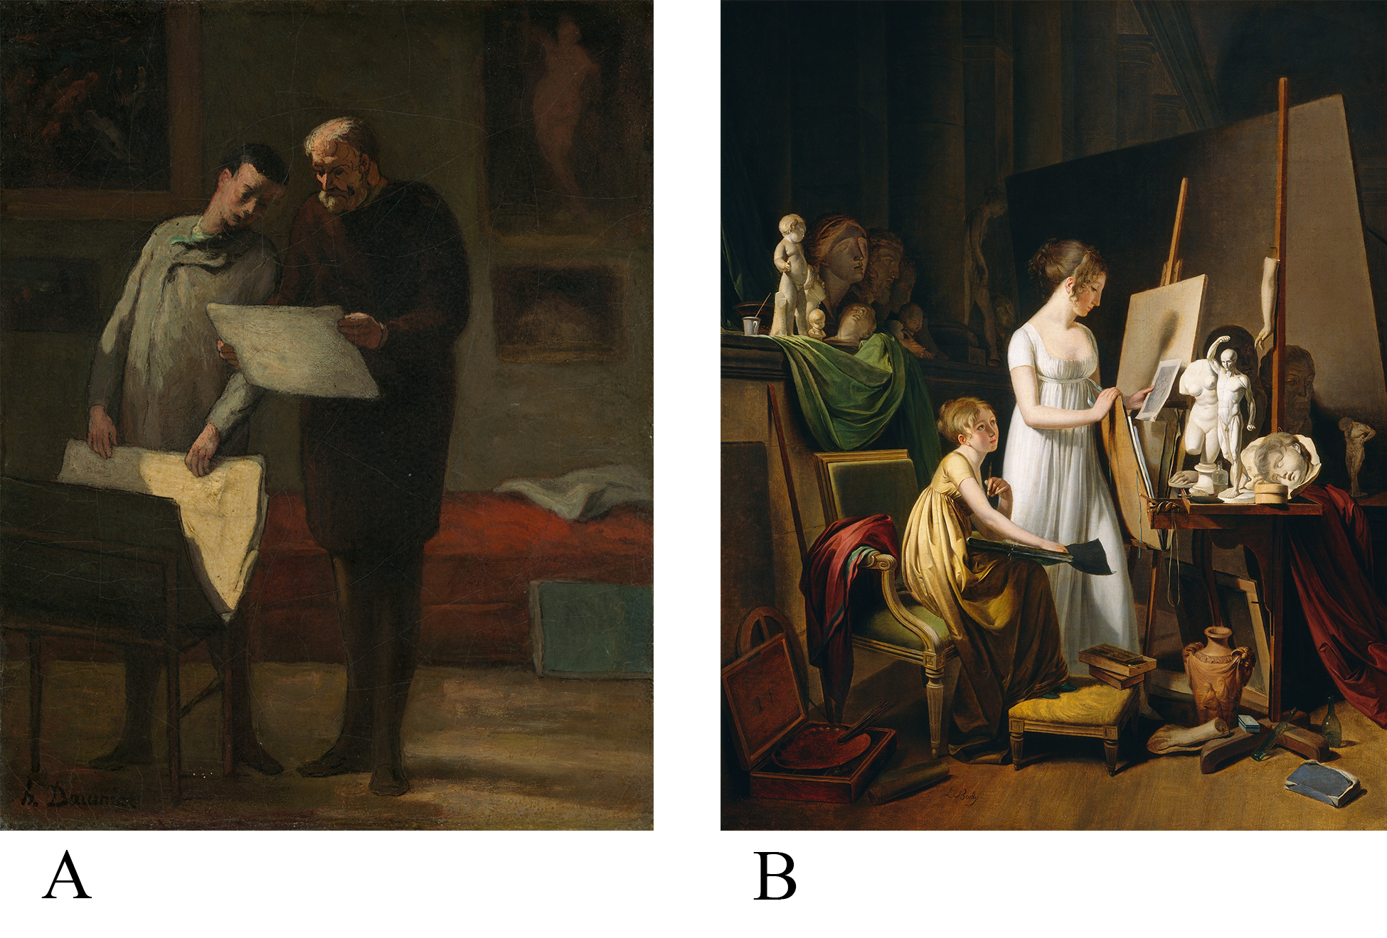

Figure 2A and 2B. Dipictions of artists in their studios.

Figure 2A shows. Honoré Daumier. (1865/1868). *Advice to a Young* Artist, 1865/1868. [oil on canvas]. National Gallery of Art, Washington D.C., USA. Whereas Figure 2B shows Jean-Baptiste-Camille Corot. (c. 1800). *A Painter’s Studio*. [oil on canvas]. National Gallery of Art, Washington D.C., USA

If you have a large caption description or other information relating to the figure/table, that you want to have appear all on one line as the caption, but not be included in the List of Figures/Tables; you will need to follow one of suggested methods. The first step is to enter a paragraph return where you want the main caption to end. Then put your cursor on the line of the extended caption or caption description. Then select the style Caption Description to no longer have that portion be associated with the same Caption style. If you are on a PC, put your cursor on the line with the main caption. Then press **Ctrl+Alt+Enter**. This will add a style separator.

If you are using a Mac, enter the paragraph return and style the extended caption as previously mentioned. Next click and highlight the paragraph return mark that follows the main caption. With that highlighted, open the Font menu on the Home ribbon. Select hidden under the effects section. When the PDF is generated, this mark will be hidden, and the line will appear as a continuous caption.

### Customized Numbering and Resetting the Number Count

There will sometimes be occasions that you need to restart the numbering of your figures or to add extra descriptors to the caption label. For instance, if you wanted to start a sequence of figures that were related and wished to express them as Figure 1A and Figure 1B; you will need to configure the sequence settings in the code behind that caption. Please follow this guide to learn how: [Advanced Caption Numbering Solutions](https://pitt.libguides.com/c.php?g=845948&p=8645727). However, you can also add text to your caption labels and have it show up in your List of Figures, as long as you don’t’ delete the number sequencer.



Figure 3A. A graph made from building blocks.



Figure 3B. A graph made from colored pencils.

You can often add customized descriptions to your captions, but you need to make sure to have inserted them using the Insert Caption command first.

## Table Formatting

A table is generally a set of facts or figures systematically displayed in columns and rows. There aren’t any defined formatting rules for tables. Be sure to use a font family that is easy to read and a font weight that isn’t too small to understand when your ETD will be in microform format. The use of color is acceptable but be mindful of using any cell shading values that may be similar to the font color.

Table 1 Captions Go Above for Tables

|  |  |  |
| --- | --- | --- |
| Particle | Discoverer | Year of Discovery |
| Electron | Joseph J. Thomson | 1897 |
| Proton | Ernest Rutherford | 1919 |
| Neutron | James Chadwick | 1932 |
| Positron | Carl D. Anderson | 1932 |

The table does not need to be inserted on the page where it is discussed in the text. If the table will not fit on the page where it is first mentioned, we strongly suggest that it either be on the next page or separated in a logical manner across the page break. You should use Page Breaks when possible, so that the table occurs at the top of the next page. Try to also organize the surrounding text to fill in the space that the table would have occupied in the previous page.

To add a caption, select the table using the table control box and then right-click to select Insert Caption. You can add caption descriptions after the table or directly after the caption, depending on your preference.

## Updating the List of Figures or List of Tables

When adding new table or figure captions, you will need to update the related lists manually. Return to the list of figures/tables in the preliminary section and right click (Ctrl+click on a Mac) on one of the listed items in the relative list. Then select Update Field – Update Entire Table, so that any new or edited content is reflected there. If you hover over any update listings and it appears as a file location on your hard drive and doesn’t show **CTRL+Click to Follow Link**, there is some issue occurring at the location of that caption. Please review our instructions for inserting captions and update the list after making those edits.

## Cross-references for Linked Items

It is often much easier to keep your links to features such as figures and tables or heading levels, by using the cross-reference feature under the References section. By using this feature you are able to create a reference link to the caption or heading you have inserted. The benefit of this feature is that if the numbering changes for the item being referenced, the cross-reference can also be updated throughout the document.

## Permissions and Original Creations

It is important to obtain permission to include any material that is copyrighted by someone else. This includes maps, drawings, tables, figures, photographs, sound files, and video clips, among others.

* + - * 1. Appendices and Supplemental Content

Appendices contain supplementary or illustrative material or explanatory data too lengthy to be included in the text or not immediately essential to the reader’s understanding of the text.

When using the Appendix Style, type the title of the Appendix section after the inserted heading. To insert a subsection in the Appendix, use the App Section Style to create each subsection and App Subsection for the third level within each main Appendix level.

Tables and Figures

To caption any tables or figures in your Appendices, you can continue to use the same caption labels that are in the main body of your ETD. However, you are able to add custom labels to differentiate your captions that are used in your Appendices.

A paragraph return symbol.

Appendix Figure 1 Paragraph Mark

Be sure to use the Appendix Figure or Appendix Table labels if you wish to start a new numbering format for these figures. If you want to continue the numbering sequence from the body of the tex, simply use the labels Figure or Table

To create alternate Appendix Figure/Table caption labels, begin by inserting a caption as you would for any other figure or table. Then use the new label button to specify a new label for the caption. You will need to either create a separate list of figures/tables for these labels or use the ETD formatting guide for creating custom Appendix labels. Please refer to our guide on creating custom labels found here: <https://pitt.libguides.com/etdsupport/captions>.

It's important to note that using the alternate numbering style that includes the chapter/heading numbers in the caption doesn’t function properly in the Appendices. You will need to create custom labels to have your captions appear as Figure A.1. Please contact ETD Support (<https://etd.pitt.edu/help>) for assistance in creating labels such as this.

Subsection Example and Appendix Captioning Advice

You aren’t required to create custom numbering sequences for your Appendix figures and tables. If you prefer to continue the figure and table numbering used in the body of your ETD, just add the same caption for figures or tables. The only issue that might come up is if you choose to adjust the numbering of your captions to include the chapter numbers. Because the Appendices aren’t technically using the same Heading hierarchy, they won’t continue the numbering for the body Headings. In this case, it might be best to use the custom caption labels and manually add the Appendix heading levels after creating the caption. You will then need to reset the Appendix caption numbering by following this guide: Advanced Caption Numbering Solutions. .

Appendix Table 1 Letters and Number

|  |  |  |  |
| --- | --- | --- | --- |
| **Letters** | **Numbers** | **More Letters** | **More Numbers** |
| efg | 456 | efg | 456 |
| hij | 789 | hij | 789 |
| abc | 123 | abc | 123 |

Appendix Table 1 Letters and Number (continued)

|  |  |  |  |
| --- | --- | --- | --- |
| **Letters** | **Numbers** | **More Letters** | **More Numbers** |
| hij | 789 | hij | 789 |
| abc | 123 | abc | 123 |
| efg | 456 | efg | 456 |
| hij | 789 | hij | 789 |

Adding Supplemental Documents

To add supplemental documents such as letters, survey forms, or published articles; it is not advised to try and embed the PDF versions or these files. You may want to upload the supporting documents alongside your ETD PDF in D-Scholarship@Pitt and reference them in your Appendices. This allows you to preserve the format of the original document and allows you to include materials that may not be embedded in a Word document. Please refer to our guide on Adding [Supplemental Files and Research Data - Electronic Theses and Dissertations Support Guide - LibGuides at University of Pittsburgh](https://pitt.libguides.com/etdsupport/supplementalfiles).

# Bibliography

To enter references for your work use the Bibliography Entry style. Single-spaced within entries. Usually ‘hanging’ from the second line on, like this. The default format will be block justified but you can make the entries left justified if desired. (The latter often helps URLs not cause spacing issues.)

Here are some examples from different styles.

Author's last name, first name. Book title. Additional information. City of publication: Publishing company, publication date. [MLA]

Author's last name, first initial. (Publication date). Book title. Additional information. City of publication: Publishing company.

Author’s last name, first name. "Title." Journal Title. Volume number, Issue number. (Publication date): pages. [DOI](https://doi-org.exproxy.umuc.edu/10.1086/683541). [Chicago]

You can use discipline specific citation styles, but these should be consistent and accurately generated following the style guide most commonly used in your discipline.

1. This is the standard rule but if your Student Services staff member doesn’t require this placement, feel free to adjust the figure/table captions to be consistently above or below, as you find more suitable.